# Question 1

A common form of interaction is through the use of menus. Discuss this form of interaction in terms of:

1. General advantages and disadvantages of menus (give 2 advantages and 2 disadvantages of menus)

Pros: (i) Self-explanatory on what can be done (ii) No need to remember command names. (iii) Minimal typing (iv) Any subsequent enhancement to program is visible as new or changed menu items.

Image

Cons: (i) Forces user to go through sequences. (ii) Items need careful organisation (iii) Takes up screen space (iv) Can’t cope with too many options.

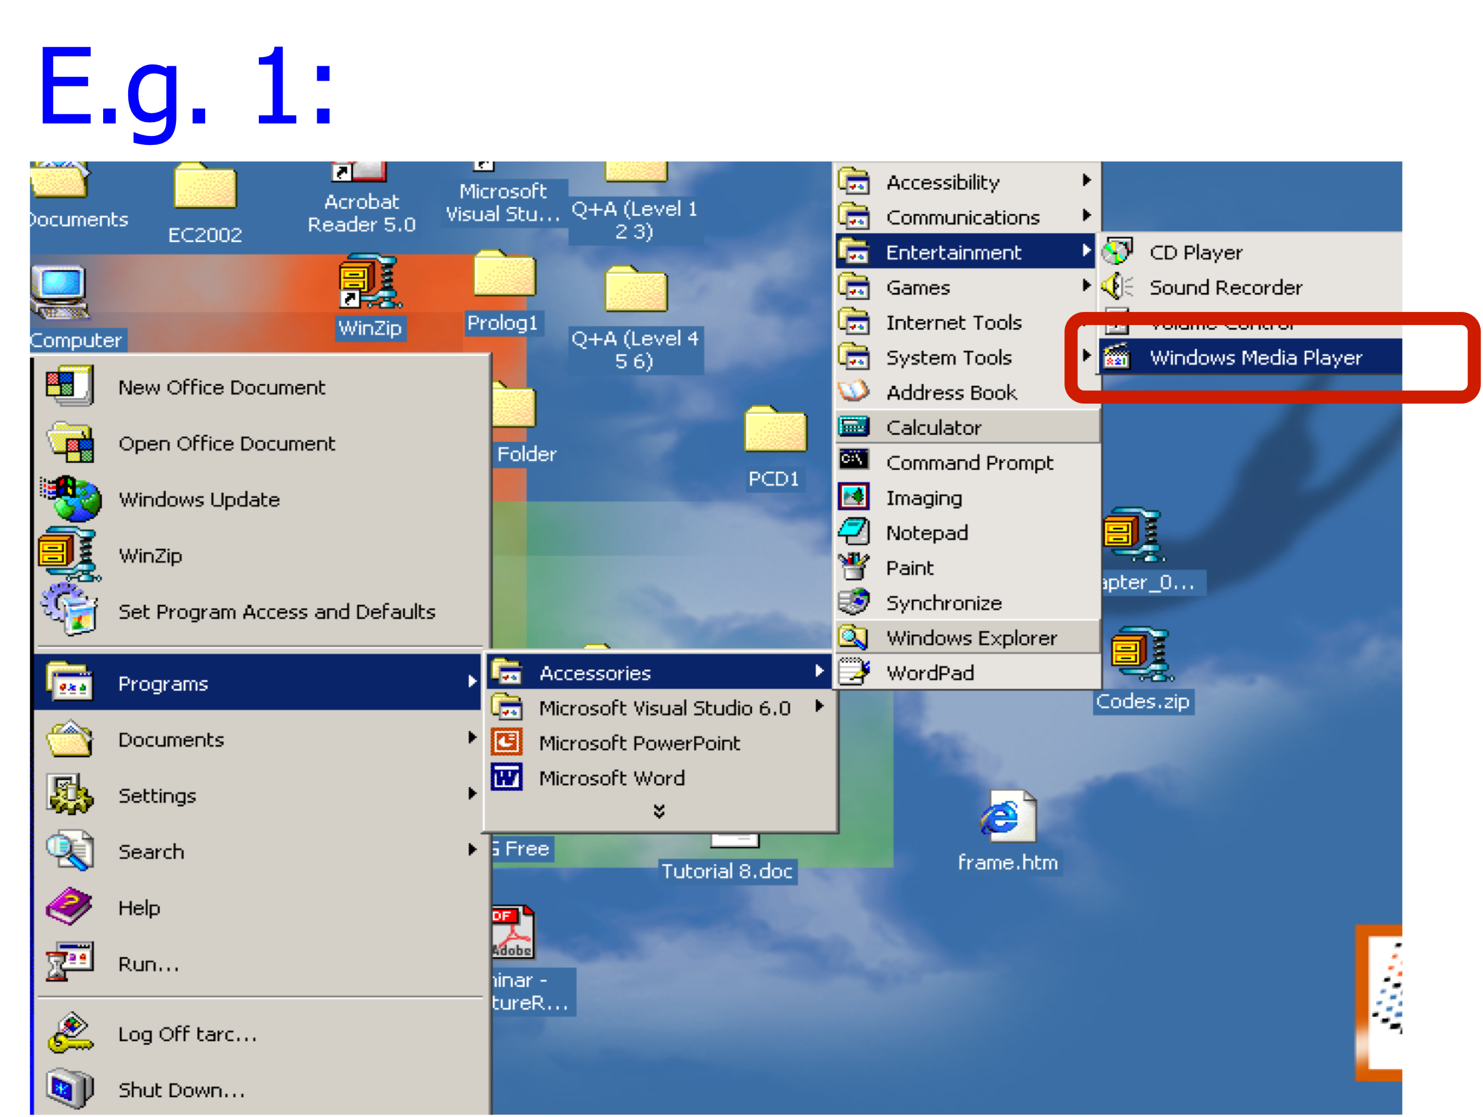

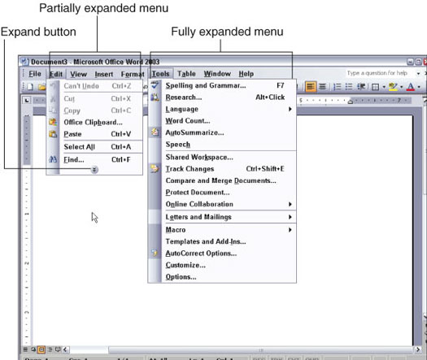

1. List all the ways of ordering/organising menu items. For each way give an example (**own example**) to support your answer.

* Category - file manager organised in a tree structure of folders and files
* Convention – cut/copy/paste menu
* Alphabetical – list of functions
* Frequency/Order of use

1. Do some research to find out other possible ways/choices of ordering menu items. List out those ways/choices not covered in the lecture. Explain your answer.

Hamburger menu – used to organized menu items on the mobile apps and mobile website, due to the limited space in the mobile screen. As you can see below diagram desktop version vs mobile version of the same website. Responsive web design.

https://www.artonicweb.com/learn/web-design-trend-hamburger-menu/

Drop down menu on the mobile devices, cannot be too long, until the user cannot reach the menu items, the user may have to switch to desktop view or change the orientation of the screen to be able to view the drop down menu items.

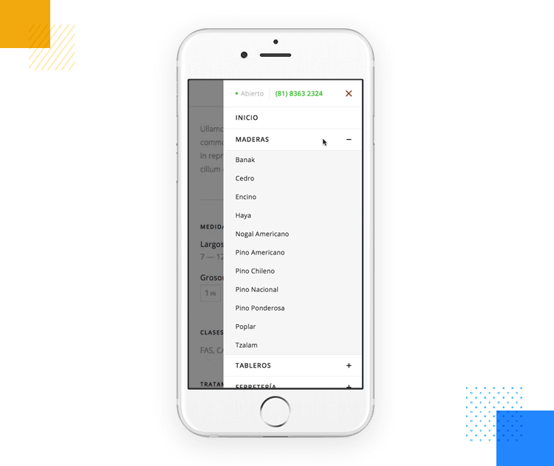

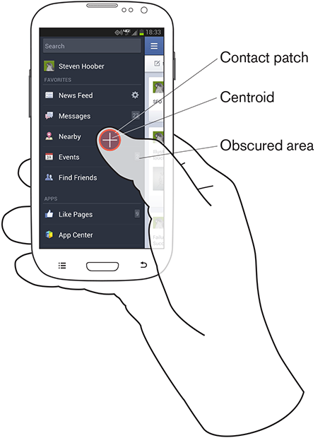

<https://ux247.com/mobile-usability-testing-fat-finger-syndrome/>

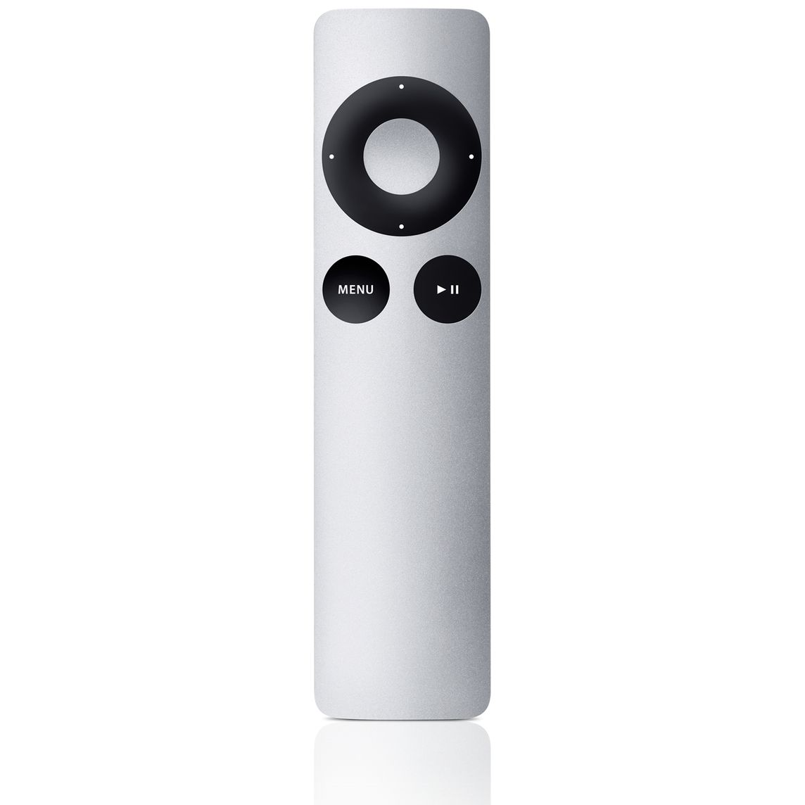



Apple TV remote controls VS Microsoft TV remote controls (red route principles)

## **Question 2** ***(Present your answers using PowerPoint slides)***

1. Linda is a new programmer working with you in a software development company. She requested assistance from you to give her some advice on how to design an effective form. Write 5 design guidelines for fill-in form that you think might help her. Explain your answer.

**Some guidlines in designing Fill-in Form:**

* **Organisation & layout**
* **Caption & field design**
* **Input formats**
* **Error handling**
* **Completion signal to support user control**
* **Refer to chapter 6 lecture slides for more details**

[**https://www.nngroup.com/articles/web-form-design/**](https://www.nngroup.com/articles/web-form-design/)

## Place the label closer to the associated text field than to other text fields.

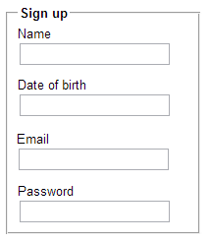

## Group together related fields.

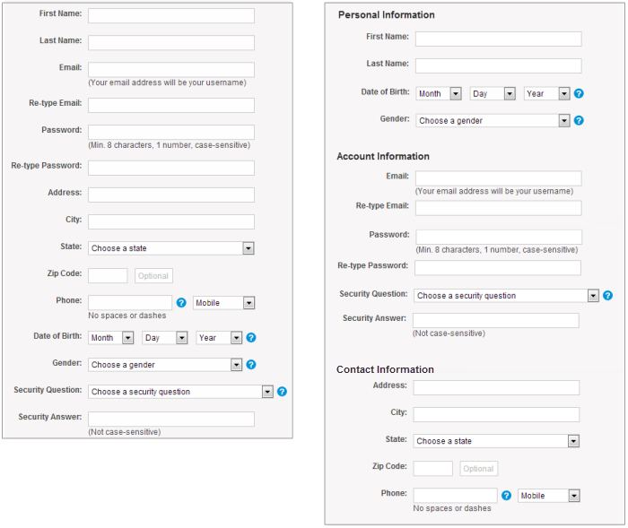

**Explain any input or formatting requirements**. If a field requires a specific format or type of input, state the exact instructions. Don’t make users guess your obscure password requirements.

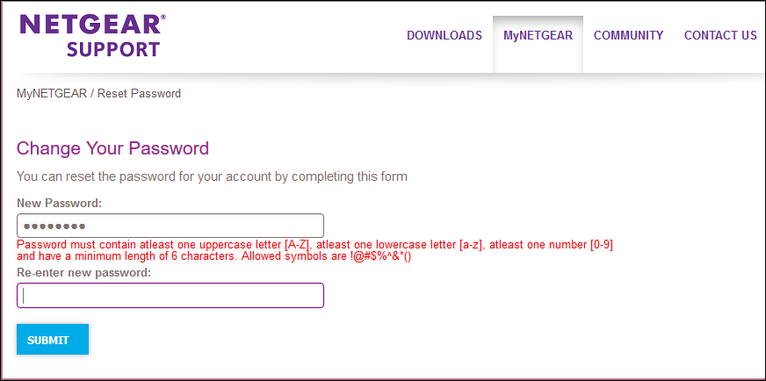

1. Find a fill-in form (onscreen or paper fill-in form) which you think is well designed and another one which you think is poorly designed. Share with the class both forms during tutorial. Explain your answer.



**Question 3**

Based on what you have learned in HCI, design a new *examination attendance slip* to replace the existing one. The examinationattendance slip must contain the following fields:

**Seat no, Index no (in words), Index no (in figures), Paper examined (as printed on the exam paper), Date of examination, Time of examination, Signature.**

Show how it would appear on paper and briefly explain the rationale of your design.

Seat number to mark off student seat. Hence important.

Then verify against student “index” and paper he’s taking.

And confirmed with the date & time of example.

And finally signature is for student to acknowledge everything written.

Seat A12

Index No (spelt): W Two Two Five Index No (code) W225

Paper: HCI 123

Date : 13th August 2021

Time : 9.00am – 12.00pm Signature : TKH